I chose to do question 26.3 and 26.4

Exercise 26.3
Index.xhtml
<?xml version='1.0' encoding='UTF-8' ?>
<!-- index.xhtml -->
<!-- Registration form that demonstrates various JSF components -->
<!DOCTYPE html PUBLIC "-//W3C//DTD XHTML 1.0 Transitional//EN"
"http://www.w3.org/TR/xhtml1/DTD/xhtml1-transitional.dtd">
<html xmlns="http://www.w3.org/1999/xhtml"
xmlns:h="http://java.sun.com/jsf/html"
xmlns:f="http://java.sun.com/jsf/core">
<h:head>
<title>Sample Registration Form</title>
</h:head>
<h:body>
<h:form>
<h1>Registration Form</h1>
<p>Please fill in all fields and click Register</p>
<h:panelGrid columns="4" style="height: 96px; width:456px;">
<h:graphicImage name="fname.png" library="images"/>
<h:inputText id="firstNameInputText" required="true"
requiredMessage="Name must be fewer than 30 characters"
value="#{validationBean.firstName}"
validatorMessage="Name must be less than 30 characters">
<f:validateLength maximum="30" />
</h:inputText>
<h:graphicImage name="lname.png" library="images"/>
<h:inputText id="lastNameInputText" required="true"
requiredMessage="Name must be fewer than 30 characters"
value="#{validationBean.lastName}"
validatorMessage="Name must be less than 30 character">
<f:validateLength maximum="30"/>
</h:inputText>
<h:graphicImage name="email.png" library="images"/>
<h:inputText id="emailInputText" required="true"
requiredMessage="Please enter a valid email number"
value="#{validationBean.email}"
validatorMessage="Invalid email format">
<f:validateRegex pattern=
"\w+([-+.']\w+)*@\w+([-.]\w+)*\.\w+([-.]\w+)*" />
</h:inputText>
<h:graphicImage name="phone.png" library="images"/>
<h:inputText id="phoneInputText" required="true"
requiredMessage="Please enter a valid phone number"
value="#{validationBean.phone}"
validatorMessage="Invalid phone number format">
<f:validateRegex pattern=
"((\(\d{3}\) ?)|(\d{3}-))?\d{3}-\d{4}" />
</h:inputText>
</h:panelGrid>
<p><h:graphicImage name="publications.png" library="images"/>
<br/>Which book would you like information about?</p>
<h:selectOneMenu id="booksSelectOneMenu">
<f:selectItem itemValue="CHTP"
itemLabel="C How to Program" />
<f:selectItem itemValue="CPPHTP"
itemLabel="C++ How to Program" />
<f:selectItem itemValue="IW3HTP"
itemLabel="Internet &amp; World Wide Web How to Program" />
<f:selectItem itemValue="JHTP"
itemLabel="Java How to Program" />
<f:selectItem itemValue="VBHTP"
itemLabel="Visual Basic How to Program" />
<f:selectItem itemValue="VCSHTP"
itemLabel="Visual C# How to Program" />
</h:selectOneMenu>
<p><h:outputLink value="http://www.deitel.com">
Click here to learn more about our books
</h:outputLink></p>
<h:graphicImage name="os.png" library="images"/>
<h:selectOneRadio id="osSelectOneRadio">
<f:selectItem itemValue="WinVista" itemLabel="Windows Vista"/>
<f:selectItem itemValue="Win7" itemLabel="Windows 7"/>
<f:selectItem itemValue="OSX" itemLabel="Mac OS X"/>
<f:selectItem itemValue="Linux" itemLabel="Linux"/>
<f:selectItem itemValue="Other" itemLabel="Other"/>
</h:selectOneRadio>
<h:commandButton value="Register"/>
<h:outputText escape="false" value="#{validationBean.result }"/>
</h:form>
</h:body>
</html>

Validation.java
/*
* To change this license header, choose License Headers in Project Properties.
* To change this template file, choose Tools | Templates
* and open the template in the editor.
*/

/**
*
* @author eg08014
*/
package validation;

import java.io.Serializable;
import javax.faces.bean.ManagedBean;

@ManagedBean(name= "validationBean")
public class ValidationBean
implements Serializable {

private String firstName;
private String lastName;
private String email;
private String phone;

// return the name String
public String getFirstName() {
return firstName;
} // end method getName

// set the firstName String
public void setFirstName(String firstName) {
this.firstName
= firstName;
} // end method setFirstName

// return the lastName String
public String getLastName() {
return lastName;
} // end method getLastName

// set the lastName String
public void setLastName(String lastName) {
this.lastName
= lastName;
} // end method setLastName

// return the email String
public String getEmail() {
return email;
} // end method getEmail

// set the email String
public void setEmail(String email) {
this.email
= email;
} // end method setEmail

// return the phone String
public String getPhone() {
return phone;
} // end method getPhone

// set the phone String
public void setPhone(String phone) {
this.phone
= phone;
} // end method setPhone

// returns result for rendering on the client
public String getResult() {
if (lastName
!= null
&& firstName
!= null
&& email
!= null
&& phone
!= null) {
return "<p style=\"background-color:yellow;width:200px;"
+ "padding:5px\">LastName: "
+ getLastName()
+ "<br/>FirstName"
+ getFirstName()
+ "<br/>E-Mail: "
+ getEmail()
+ "<br/>Phone: "
+ getPhone()
+ "</p>";
} else {
return ""; // request has not yet been made
}
} // end method getResult
} // end class ValidationBean

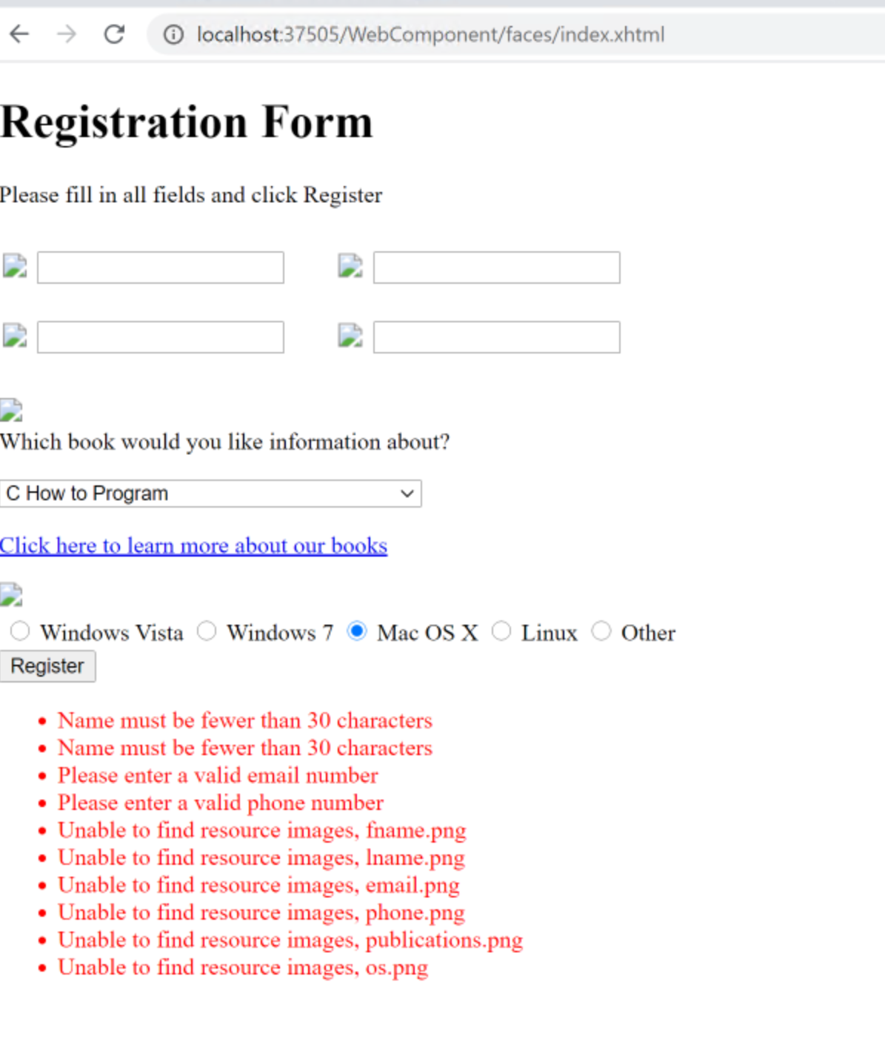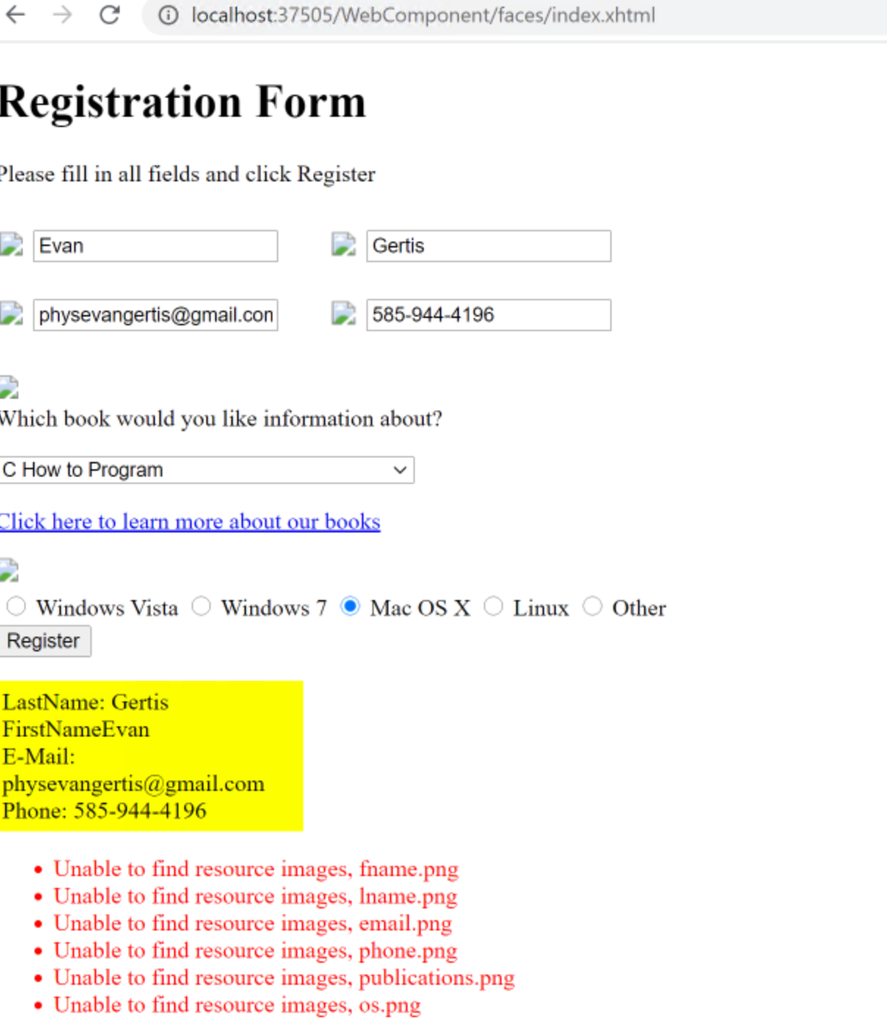

Exercise 26.4
Index.xhtml
<!-- Allow the user to select a topic -->
<!DOCTYPE html PUBLIC "-//W3C//DTD XHTML 1.0 Transitional//EN"
"http://www.w3.org/TR/xhtml1/DTD/xhtml1-transitional.dtd">
<html xmlns="http://www.w3.org/1999/xhtml"
xmlns:h="http://java.sun.com/jsf/html"
xmlns:f="http://java.sun.com/jsf/core"
xmlns:c="http://xmlns.jcp.org/jsp/jstl/core">
<h:head>
<title>Topic Selection Page</title>
</h:head>
<h:body>
<h1>Welcome to Sessions!</h1>
<p>You have made #{selectionsBean.numberOfSelections} selection(s)</p>
<h3>Make a Selection and Press Submit</h3>
<h:form>
<h:selectOneRadio id="topicSelectOneRadio" required="true"
requiredMessage="Please choose a topic, then press Submit"
value="#{selectionsBean.selection}">
<f:selectItem itemValue="java" itemLabel="Java"/>
<f:selectItem itemValue="cpp" itemLabel="C++"/>
<f:selectItem itemValue="iphone" itemLabel="iPhone"/>
<f:selectItem itemValue="android" itemLabel="Android"/>
</h:selectOneRadio>
<p><h:commandButton value="Submit"/></p>
</h:form>
<p><h:outputLink value="shoppingCart.xhtml">
Click here to view your shopping cart
</h:outputLink></p>
</h:body>
</html>

shoppingCart.xhtml
<?xml version='1.0' encoding='UTF-8' ?>

<!-- index.xhtml -->
<!-- Allow the user to select a topic -->
<!DOCTYPE html PUBLIC "-//W3C//DTD XHTML 1.0 Transitional//EN"
"http://www.w3.org/TR/xhtml1/DTD/xhtml1-transitional.dtd">
<html xmlns="http://www.w3.org/1999/xhtml"
xmlns:h="http://java.sun.com/jsf/html"
xmlns:f="http://java.sun.com/jsf/core"
xmlns:c="http://xmlns.jcp.org/jsp/jstl/core">
<h:head>
<title>Topic Selection Page</title>
</h:head>
<h:body>
<h1>Shopping Cart</h1>
<ul>
<c:forEach var="item" items="${selectionsBean.selections}">
<li>
<label>Title: #{item.title}</label>
<p>Genre: #{item.genre}</p>
<p>Price: #{item.price}</p>
</li>
</c:forEach>
</ul>
<p>Total: #{selectionsBean.selections.stream().map(book -> book.price).sum()}</p>
<p><h:outputLink value="index.xhtml">
Click here to go back to selections
</h:outputLink></p>
</h:body>
</html>

Selections.java
/*
* To change this license header, choose License Headers in Project Properties.
* To change this template file, choose Tools | Templates
* and open the template in the editor.
*/
package sessiontracking;

/**
*
* @author eg08014
*/

import java.io.Serializable;
import java.util.HashMap;
import java.util.Set;
import java.util.ArrayList;
import java.util.List;
import java.util.HashSet;
import javax.faces.bean.ManagedBean;
import javax.faces.bean.SessionScoped;

@ManagedBean(name="selectionsBean")
@SessionScoped
public class Selections {
// map of topic to book titles

public static class Book {

public Book(String genre, String title, int price){
this.genre = genre;
this.title = title;
this.price = price;
}

public String getTitle(){
return title;
}

public String getGenre(){
return genre;
}

public int getPrice(){
return price;
}

public String title;
public String genre;
public int price;
}

private static final HashMap<String, Book> selectionsMap = new HashMap<String, Book>();

static
{
selectionsMap.put("java",new Book("java","Java How to Program",10));
selectionsMap.put("cpp", new Book("iphone","How to program iOS",20));
selectionsMap.put("iphone", new Book("android", "How to program android", 20));
selectionsMap.put("android", new Book("cpp","C++ How to program", 15));
}

private List<Book> selections = new ArrayList<Book>();
private String selection;

public int getNumberOfSelections(){
return selections.size();
}

public String getSelection(){
return selection;
}

public void setSelection(String topic){
String genre = selectionsMap.get(topic).genre;
selection = selectionsMap.get(topic).title;
selections.add(selectionsMap.get(genre));
}

public List<Book> getSelections(){
return selections;
}
}

